I. INTRODUCTION

In the fast-paced world of recruitment, the sheer volume of resumes received for a single job opening can be overwhelming for hiring teams. Traditional methods of manually screening and evaluating each application are not only time-consuming but also prone to oversights. In response to these challenges, our project endeavors to redefine the recruitment landscape by harnessing the power of Natural Language Processing (NLP) tools, with a primary focus on spaCy, to conduct a comprehensive analysis of 200 resumes.
The core objective of this initiative is to usher in a new era of efficiency and accuracy in the candidate screening process. By leveraging spaCy's advanced capabilities in entity recognition, we aim to automate the extraction of crucial information from resumes, enabling recruiters to swiftly navigate through a large dataset and make well-informed decisions.
Our approach involves a strategic integration of spaCy as the primary NLP library, backed by a meticulous entity ruler crafted from a curated list of skills. This dual-pronged strategy not only ensures the extraction of key entities related to skills, qualifications, and experience but also introduces a ground breaking skills matching feature.
This feature provides hiring managers with a quantitative metric, allowing them to assess the alignment between applicants' skills and the job requirements. The project operates on two distinct datasets: the first containing the textual content of 200 resumes, offering a diverse spectrum of candidate profiles, and the second comprising a meticulously curated list of skills.
The synergy between spaCy's entity recognition and the custom entity ruler dedicated to skills matching positions our project at the forefront of innovation in resume analysis. Through the seamless integration of NLP techniques, we anticipate a significant reduction in the time and effort traditionally invested in resume screening. This research not only marks a pioneering effort in leveraging advanced NLP tools for high-volume recruitment but also promises a scalable and effective solution for modern talent acquisition processes. By empowering hiring managers with a rapid yet precise mechanism for candidate evaluation, our project aims to streamline the recruitment pipeline, ensuring that only the most qualified applicants progress to the interview stage.
In the ever-evolving realm of recruitment, the inundation of resumes for a single job opening can overwhelm hiring teams. The conventional method of manual screening and evaluation is not only time-consuming but also prone to oversights. In response to these challenges, our groundbreaking project seeks to redefine the recruitment landscape by harnessing the power of Natural Language Processing (NLP) tools, with a specific focus on the spaCy library. This initiative aims to conduct a thorough analysis of 200 resumes, introducing a new era of efficiency and accuracy to the candidate screening process. Our primary objective is to automate the extraction of crucial information from resumes, enabling recruiters to navigate swiftly through a vast dataset and make well-informed decisions. We leverage spaCy's advanced capabilities in entity recognition, with a strategic integration as the primary NLP library. This integration is further enhanced by a meticulous entity ruler crafted from a curated list of skills, providing a dual-pronged strategy for extracting key entities related to skills, qualifications, and experience. The innovative skills matching feature introduced in our approach offers hiring managers a quantitative metric to assess the alignment between applicants' skills and job requirements. By introducing this groundbreaking feature, we provide a unique solution that not only extracts information but also evaluates its relevance, thus streamlining the decision-making process for recruiters. In the dynamic and fast-paced realm of recruitment, the inundation of resumes for a single job opening poses a formidable challenge for hiring teams. The traditional method of manual screening and evaluation, while a staple in the hiring process, becomes increasingly inefficient and error-prone when faced with the sheer volume of applications. Recognizing these challenges, our innovative project emerges as a groundbreaking effort to redefine the recruitment landscape. Leveraging the transformative capabilities of Natural Language Processing (NLP) tools, with a specific emphasis on the spaCy library, our initiative aims to introduce a new era of efficiency and accuracy to the candidate screening process.
The core objective of our project is to address the time-consuming nature of traditional resume screening methods by automating the extraction of crucial information from resumes. With a focus on analyzing a dataset comprising 200 resumes, our goal is to empower recruiters to swiftly navigate through this substantial volume of applications while ensuring well-informed decision-making. At the heart of our approach is the strategic integration of spaCy as the primary NLP library, renowned for its advanced entity recognition capabilities.
To enhance the precision of our automated resume analysis, we introduce a dual-pronged strategy by complementing spaCy with a meticulously crafted entity ruler. This ruler is derived from a curated list of skills, allowing for the extraction of key entities related to skills, qualifications, and experience. However, our project does not stop at information extraction. We aim to set a new standard in resume analysis by introducing a ground breaking skills matching feature. This innovative feature goes beyond mere entity extraction; it provides hiring managers with a quantitative metric to assess the alignment between applicants' skills and job requirements. By introducing this unique solution, our project contributes to streamlining the decision-making process for recruiters, ensuring not only the extraction of information but also its evaluation for relevance. The project operates on two distinct datasets: the first containing the textual content of 200 resumes, offering a diverse spectrum of candidate profiles, and the second comprising a meticulously curated list of skills.
The strategic synergy between spaCy's entity recognition and our custom entity ruler positions our project at the forefront of innovation in resume analysis. As we anticipate a significant reduction in the time and effort traditionally invested in resume screening, this research marks a pioneering effort in leveraging advanced NLP tools for high-volume recruitment. By empowering hiring managers with a rapid yet precise mechanism for candidate evaluation, our project aims to streamline the recruitment pipeline, ensuring that only the most qualified applicants progress to the interview stage. In the ever-evolving realm of recruitment, our project represents a beacon of progress, promising a scalable and effective solution for modern talent acquisition processes.

II. REVIEW OF LITERATURE

Channabasamma et al [1]: This paper suggests a machine learning method for phrase matching in resumes, utilizing the advanced natural language processing (NLP) library spaCy to extract particular skills. Like a human recruiter, it is capable of analyzing resumes and extracting comprehensive information. In order to classify people according to their level of expatriation, it counts the sentences during parsing. Data visualization with matplotlib can expedite the decision-making process. It is possible to weed out candidates by comparing them side by side.
Chavare, Dipti Suhas et al [2]: This article uses advanced Natural Language Processing to automate the screening of resumes. Our methodology assists recruiters in quickly screening resumes in accordance with job descriptions. By automatically extracting the necessary entities from resumes using the Spacy NER model, it streamlines the hiring process. Additionally, joint NER and relation extraction offer a whole new way to retrieve information using knowledge graphs, allowing you to explore different nodes to uncover hidden relationships.
Satheesh, K., A. Jahnavi et al [3]: This paper inefficiencies of manual resume screening in traditional hiring processes and proposes an automated solution using advanced Natural Language Processing (NLP) within the realm of Machine Learning. The model employs Spacy NER for entity extraction, streamlining the screening process and providing recruiters with a graphical representation of candidate scores. This approach not only accelerates hiring but also enhances efficiency by enabling recruiters to swiftly identify and select qualified candidates based on their individual scores.
Shukla, Anant [4]: Beyond simple spell checking, the applicant tracking system (ATS) grades applications using cutting edge AI technology based on many checks that hiring managers and recruiters review. In particular, the platform assesses word choice strength and verifies application style and brevity in order to analyze the impact of the application. In a similar vein, it evaluates every application bullet point and looks for important components including length, word choice, filler words, keywords, and buzzwords.

Vanetik, N. and Kogan [5]: We provide a dataset of software developer resumes in this paper, taken from a public Telegram channel devoted to Israeli hi-tech job applications. Furthermore, to attain state-of-the-art performance in resume matching, we offer an NLP-based method that makes use of named entities, keywords, and neural sentence representations. We compare our method against the top resume-vacancy matching system and show its superiority using both automatic and human annotations.
Bhoir, Nirmiti et al [6]: The two algorithms' best features are combined in this work to obtain highly accurate and effective resume data collection. We conducted experiments to measure the effectiveness of our proposed approach using a dataset of resumes. The results show how accurately our system was able to retrieve relevant data, such as candidate names, contact details, qualifications, job history, and other relevant attributes.
Brindashree, B.V. and Pushphavathi [7]: The decision tree machine learning model, which had a 70% accuracy rate, was trained to make the prediction. The data's precision, recall, and f1 score are acquired and used to assess how successfully the data was trained. Overall, the initiative will streamline HR duties and automate procedures, which will shorten the duration of the hiring process.
S. Hashwanth et al [8]: Recruiters may easily shortlist resumes fast and effectively by processing the document ranking and displaying the final rankings in descending order based on the resume score. Instead of going through piles of unqualified resumes, recruiters may select the necessary candidates based on the scores.
Tanberk, Senem et al [9]: The suggested resume matching framework lets managers or recruiters choose the top-scoring applicants by precisely extracting pertinent information from resumes and displaying the similarity results of the candidates through sorting and ranking.
Chavare, Dipti Suhas et al [10]: This article uses advanced Natural Language Processing to automate the screening of resumes. Our methodology assists recruiters in quickly screening resumes in accordance with job descriptions. By automatically extracting the necessary entities from resumes using the Spacy NER model, it streamlines the hiring process. Additionally, joint NER and relation extraction offer a whole new way to retrieve information using knowledge graphs, allowing you to explore different nodes to uncover hidden relationships.
Sruthi, P., Adithya et al [11]: The information on the resume can be analysed and understood easily as NLP has the capability to understand and parse the information on the resume and extract the desired information efficiently. With the additional help from Python and its packages like streamlit, pymysql, etc. we can store the extracted data and give a rating based on the analysis of the stored data. After the rating is generated, we recommend some modifications like: adding sentences like my hobbies are, my goal is, add objectives, and add declaration and more. We also suggest a few sources through which the user can enhance their skills.
Nimet, Gökhan Akgün et al [12]: The paper introduces robust techniques for information extraction from mixed resume formats and job advertisements, leveraging the capabilities of machine learning and deep learning methods. These methods aim to enhance the efficiency and effectiveness of extracting relevant information from diverse sources, such as resumes and job ads. The proposed approaches address the challenges posed by mixed formats, showcasing their power in handling complex data structures. Overall, the paper contributes valuable insights into advancing information extraction processes in the context of employment-related documents.
Satheesh, K., A. Jahnav et al [13]: This research utilizes advanced Natural Language Processing (NLP), a machine learning branch, to automate resume screening. The framework employs the Spacy Named Entity Recognition (NER) model to automatically extract essential entities from resumes, facilitating a swift assessment of applicants based on job descriptions. This streamlined process accelerates hiring by generating a graph depicting the scores of each resume. Recruiters can efficiently select qualified individuals without the need to sift through a large number of unqualified resumes.
Pudasaini, Shushanta et al [14]: In order to extract such structured information from a wide range of textual texts, we develop an NLP pipeline in this study. Textual materials utilized in applicant tracking systems, such as job opening information and curriculum vitae (CV), have been taken into consideration as references. Text extraction, document segmentation, and document classification are just a few of the NLP techniques that are used in the construction of the suggested pipeline. The XGBoost and support vector machines (SVM) algorithms were first used for textual document classification. NLP techniques like chunking, regex matching, and POS tagging are used to categorize different chunks of the detected material. Methods like pool parsing, regex matching, and Named Entity Recognition (NER) are used to extract more pertinent data from each segment. Taking such organized data out of the Textual documents can be used for matching, auto-filling forms, document scoring, document upkeep, and insight acquisition.
Alkeshwar Jivtode et al [15]: Thus, the suggested approach offers the potential advantages of the machine learning model to improve the hiring procedure and make it more equitable and effective. Employing natural language processing (NLP) techniques, you may accurately grade resumes according to the company's criteria and extract useful information from them. After thorough testing and improvement, Hiring managers and job candidates may find your website to be an invaluable resource. Additionally, you can think about adding features to the CV like customized comments and improvement ideas. This might assist candidates in understanding where they might be lacking and how to increase their chances of getting recruited.
Mnvsai Raghavendra et al [16]: This system could classify a lot of resumes into the appropriate categories using several classifiers, such as KNN, MLP, LR, and SVM. In addition, this system looks for the performance and correctness of the suggested methodology in order to apply it to IT companies and other regulations in order to prevent manual screening and provide a safe allocation of resources for the businesses.

III. PROBLEM STATEMENT

In today's competitive job market, the influx of job applications inundates recruiters, making it increasingly challenging for them to efficiently sift through numerous resumes to identify suitable candidates. This overload often results in time-consuming manual screening processes, leading to delays in hiring and potential oversight of qualified individuals. Moreover, traditional methods of resume analysis lack the sophistication needed to extract valuable insights from text data, hindering recruiters' ability to make informed decisions swiftly. The existing tools and techniques for resume analysis often fall short in accurately identifying relevant information such as skills, experiences, and qualifications. Manual parsing of resumes is labor-intensive and prone to human error, while keyword-based approaches lack the nuance to discern contextual relevance effectively. Additionally, the absence of automated mechanisms for skills matching further compounds the problem, as recruiters struggle to efficiently gauge candidates' suitability based on their qualifications relative to job requirements. Consequently, there is a pressing need for advanced natural language processing (NLP) techniques that can streamline the resume screening process and provide recruiters with actionable insights to expedite candidate selection while ensuring optimal match for job roles. Addressing these challenges requires leveraging cutting-edge NLP technologies such as spaCy for entity recognition and entity ruling, alongside robust algorithms for skills matching. However, the integration and optimization of these tools within the context of resume analysis pose significant technical and methodological challenges. Issues such as data preprocessing, model training, and validation of results need to be meticulously addressed to ensure the reliability and accuracy of the system. Furthermore, the practical implementation of such a system must consider scalability, usability, and compatibility with existing recruitment workflows to maximize its utility for recruiters and hiring managers. Thus, this project aims to develop an innovative solution that harnesses the power of NLP to revolutionize resume analysis, enabling recruiters to expedite candidate selection and enhance hiring efficiency in today's fast-paced job market landscape.

IV. EXISTING SYSTEM

One existing system for spaCy resume analysis is "Resumé Parser," an open-source Python library built on top of spaCy. Resumé Parser provides functionalities for parsing resumes in various formats such as PDF, DOCX, and TXT, extracting key information like personal details, work experience, education, and skills. It utilizes spaCy's natural language processing capabilities to perform entity recognition and extraction, enabling efficient parsing and structuring of resumes. Resumé Parser offers a straightforward API that developers can integrate into their applications to automate the resume screening and analysis process, saving time and effort for recruiters and HR professionals.
Another existing system is "Talent Sonar," a commercial HR software solution that leverages spaCy for resume analysis and candidate screening. Talent Sonar utilizes spaCy's NLP capabilities to parse resumes, extract relevant information, and match candidates with job requirements based on skills, experience, and qualifications. It provides advanced features such as customizable scoring algorithms and bias detection mechanisms to streamline the recruitment process and ensure fair and unbiased candidate evaluation. Talent Sonar offers a user-friendly interface for recruiters to manage and analyze resumes efficiently, helping organizations identify top talent effectively while minimizing manual effort and bias.

V. PROPOSED SYSTEM

The proposed automated resume analysis system represents a groundbreaking advancement in the field of talent acquisition, leveraging cutting-edge Natural Language Processing (NLP) techniques with a primary focus on spaCy. By integrating spaCy for entity recognition and implementing a custom entity ruler for skills matching, the system efficiently extracts key information from a dataset of 200 resumes, streamlining candidate screening. The introduction of a skills matching metric provides hiring managers with a quantitative basis for decision-making, allowing for swift identification of candidates closely aligned with job role requirements. Operating on two primary datasets, including textual content of resumes and a curated list of skills, the system optimizes efficiency, empowering recruiters with a rapid and precise mechanism for candidate evaluation. The anticipated outcomes include an effective solution for high-volume resume screening, scalability for evolving recruitment needs, and a user-friendly interface ensuring a seamless experience for recruiters. Positioned as a pioneering effort in applying advanced NLP techniques, the system is designed for continuous improvement, adapting to changing job market dynamics and emerging recruitment trends, ultimately enhancing the overall recruitment process.

VI. METHODOLOGY

The methodology for Automated Resume Analysis Using spaCy involves several key steps. Firstly, the system begins with the collection of resumes in various formats, such as PDF or DOCX. These resumes are then parsed using spaCy to extract the text content. Next, spaCy's NLP capabilities are leveraged for tasks such as named entity recognition (NER) and part-of-speech (POS) tagging to identify and extract key information from the resumes, including education history, work experience, skills, and achievements. The extracted data is then stored in a structured format in a database for easy retrieval and analysis. Additionally, the system incorporates functionalities for keyword matching and sentiment analysis to evaluate candidate suitability and match with job requirements. Finally, the results of the analysis are presented to recruiters through reports and visualizations, aiding them in making informed hiring decisions. This methodology ensures the automation of the resume analysis process using spaCy's powerful NLP capabilities, thereby streamlining the recruitment process and enhancing efficiency.
Our approach operates on two distinct datasets. The first dataset contains the textual content of 200 resumes, presenting a diverse spectrum of candidate profiles. The second dataset comprises a meticulously curated list of skills, forming the backbone of our entity ruler. The synergy between spaCy's entity recognition and the custom entity ruler dedicated to skills matching positions our project at the forefront of innovation in resume analysis.
The integration of NLP techniques, specifically spaCy, promises a significant reduction in the time and effort traditionally invested in resume screening. Our meticulously crafted entity ruler, built from a curated list of skills, adds an extra layer of precision to the process. The skills matching feature not only ensures the extraction of key entities related to skills but also introduces a groundbreaking method to quantitatively measure the alignment between applicants' skills and job requirements.

Figure 1: Resume Analysis
6.1. SPACY:
SpaCy, a robust Natural Language Processing (NLP) library, is at the forefront of transforming the landscape of resume analysis. At its core is an advanced Named Entity Recognition (NER) model that revolutionizes the way essential information is extracted from resumes. By seamlessly identifying and categorizing crucial details such as skills, experiences, and qualifications, SpaCy automates and streamlines the resume screening process with unparalleled efficiency.
This technology not only expedites the screening process but also enhances accuracy by precisely extracting relevant entities. Recruiters benefit from a comprehensive understanding of each applicant's profile, enabling them to make well-informed decisions. The intelligent automation offered by SpaCy represents a significant departure from the traditional manual screening approach, alleviating recruiters from the burdensome task of sifting through numerous resumes.
The streamlined and intelligent resume analysis powered by SpaCy empowers recruiters to optimize their decision-making process. With the reduction in time and effort associated with manual screening, recruiters can focus on evaluating the most qualified candidates, ultimately leading to more efficient and successful hiring processes. In summary, SpaCy's role in resume analysis marks a transformative advancement in the field, promising enhanced productivity and informed decision-making for recruiters.

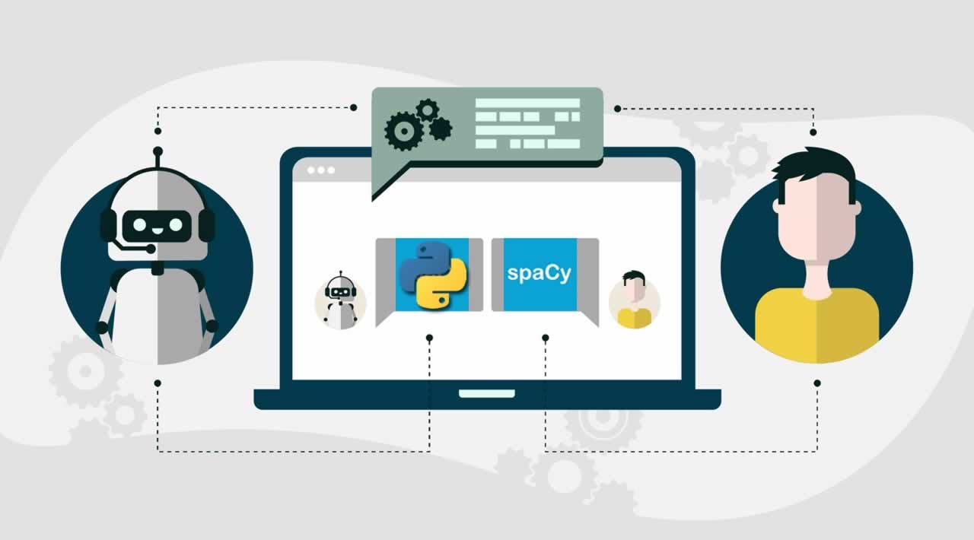

Figure 2: Spacy using NLP

6.2. Dataset:
The dataset for Automated Resume Analysis Using spaCy comprises a diverse collection of resumes sourced from various industries and professions. Each resume within the dataset contains structured information such as education history, work experience, skills, certifications, and contact details. Additionally, the resumes may include unstructured text sections, such as objective statements, job descriptions, and project summaries. The dataset covers a wide range of formats, including PDF, DOCX, and plain text, to simulate real-world scenarios. Furthermore, the dataset includes annotations for named entities, such as organizations, locations, and job titles, to facilitate the training and evaluation of spaCy's NLP models for resume parsing and information extraction. Overall, this comprehensive dataset enables the development and validation of automated resume analysis systems using spaCy, ensuring robust performance across various resume formats and content structures. The CSV dataset includes a unique identifier, "ID," which serves as both a unique identifier and the filename for the respective PDF containing the resume.
"Resume_str" column contains the textual content of the resumes in string format, facilitating text-based analysis and processing.
"Resume_html" column provides the resume data in HTML format, mirroring the original structure as presented during web scraping, enabling detailed examination of formatting and layout.
The "Category" column assigns each resume to a specific job category, offering insights into the field or industry associated with the candidate's background and experience. Job categories within the dataset span a diverse range, encompassing fields such as Human Resources (HR), Information Technology (IT), Education (Teacher), Legal (Advocate), Business Development, Healthcare, Fitness, Agriculture, Business Process Outsourcing (BPO), Sales, Consulting, Digital Media, Automobile, Culinary (Chef), Finance, Apparel, Engineering, Accounting, Construction, Public Relations, Banking, Arts, Aviation, among others. This structured dataset facilitates research and development in automated resume analysis, enabling tasks such as categorization, information extraction, and sentiment analysis, with potential applications in recruitment, talent acquisition, and workforce planning across various industries and professions.
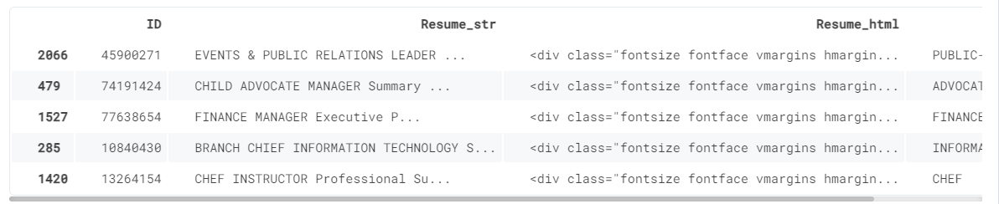

6.3. DATA FLOW DIAGRAM:

Dataset

Cleaning Resume Text
Entity Ruler

Jobs Distribution

Dependency Parsing
Visualization

Entity Recognition
Resume Analysis

pyLDAvis
LDA

Figure 3: Spacy Resume Analysis

6.4. Jobzilla skill patterns:
The Jobzilla skill patterns dataset is a valuable resource for creating a spaCy entity ruler tailored specifically for automated resume analysis. This dataset, stored in JSONL format, comprises labeled skill patterns that represent the diverse range of skills commonly found in resumes across various industries and professions. Each entry in the dataset consists of two main components: the label, which categorizes the skill, and the pattern, which includes different words or phrases used to describe that particular skill. For example, skills such as "Python programming," "data analysis," "customer service," and "project management" are represented by their respective labels and associated patterns. By incorporating this dataset into the spaCy entity ruler, the automated resume analysis system gains the ability to recognize and extract specific skills mentioned in resumes accurately. This enhances the system's capability to parse and analyze resumes efficiently, enabling recruiters to identify qualified candidates based on their skill sets more effectively. Moreover, the Jobzilla skill patterns dataset facilitates continuous improvement and customization of the entity ruler, allowing for the addition of new skills and patterns as the job market evolves over time. Overall, this dataset plays a crucial role in enhancing the accuracy and effectiveness of automated resume analysis using spaCy.
6.5. Resume Dataset:
The resume dataset is read into a Pandas Data Frame using the read_csv function, containing textual information about resumes. To ensure diversity in job categories, the dataset undergoes randomization, where 200 samples are selected from various job categories instead of being restricted to just one. This approach broadens the scope of analysis and facilitates a more comprehensive understanding of skill patterns across different professions and industries. Given the computational constraints and processing time considerations, the dataset is limited to 200 samples, striking a balance between computational efficiency and analytical depth. This sampling strategy allows for efficient analysis while still providing valuable insights into skill patterns and job categories present in resumes.
6.6. Loading spaCy model:
Once the spaCy model has been downloaded using the command "python -m spacy download en_core_web_lg," the next step involves loading the spaCy model into the Python environment. This is accomplished by importing the spaCy library and loading the model using the "spacy.load" function. The loaded model is then stored in a variable, typically named "nlp," which serves as the entry point for accessing spaCy's linguistic features and capabilities. By loading the pre-trained "en_core_web_lg" model, which is a large English language model, the system gains access to a wide range of linguistic annotations and vectors, including part-of-speech tagging, named entity recognition, and word embeddings. This rich linguistic representation provided by spaCy's model forms the foundation for various NLP tasks, including automated resume analysis.
6.7. Entity Ruler:
The addition of an entity ruler pipeline to our spaCy model is a pivotal step in enhancing the capabilities of automated resume analysis. This entity ruler empowers us to define and enforce rules for identifying specific entities within the text, such as skills and job descriptions. By loading a .jsonl file containing labeled patterns for these entities, we can instruct the entity ruler to recognize and annotate instances of these patterns in the resumes. This facilitates precise extraction of relevant information, enabling us to efficiently categorize and analyze resumes based on key attributes like skills and job roles. With the entity ruler in place, our automated resume analysis system becomes more robust and effective, providing recruiters with invaluable insights into candidate qualifications and suitability for various roles. This integration of the entity ruler pipeline represents a significant advancement in our ability to harness the power of spaCy for resume parsing and analysis, ultimately streamlining the recruitment process and enhancing decision-making.
6.8. Skills:
The unique_skills function serves as a crucial component in our automated resume analysis system, enabling us to efficiently process and organize the extracted skills. Once the get_skills function extracts skills from a single resume text, the unique_skills function removes any duplicate entries, ensuring that each skill is represented only once within the resulting array. This step is essential for creating a concise and accurate summary of the skills present in the dataset. By eliminating duplicates, we prevent redundancy and streamline subsequent analysis, allowing us to focus on identifying trends and patterns within the dataset more effectively. Moreover, the unique_skills function enhances the interpretability of the skill data, providing a clear and unambiguous representation of the skills possessed by candidates across various job categories. As a result, the creation of the skill feature, incorporating unique_skills, facilitates comprehensive visualization and analysis of skill trends within the dataset, empowering recruiters to make informed decisions in the talent acquisition process.
- get_skills is going to extract skills from a single text.
- unique_skills will remove duplicates.

6.9. Cleaning Resume Text:
Cleaning the resume text using the NLTK library involves a series of essential steps to preprocess the data effectively. Firstly, we utilize regular expressions (regex) to eliminate hyperlinks, special characters, and punctuations from the text, ensuring that only relevant content remains. Next, we convert the text to lowercase to standardize the case and avoid case sensitivity issues during analysis. The text is then split into an array based on whitespace, facilitating further processing. To normalize the text, we employ lemmatization to reduce words to their base forms, enhancing consistency and reducing the dimensionality of the data. Additionally, we remove English stopwords, such as "and," "the," and "is," which carry little semantic meaning and can skew analysis results. Finally, the cleaned and preprocessed text is appended into an array, ready for subsequent analysis tasks. This comprehensive cleaning process ensures that the resume text is appropriately prepared for further analysis and modeling, enabling accurate extraction of meaningful insights and trends from the dataset.

6.10. Applying functions:
Creating Clean_Resume Column: We add a new column called "Clean_Resume" to the dataset and populate it with the cleaned resume text obtained after applying the cleaning functions, including regex cleaning, lowercase conversion, word tokenization, lemmatization, and stopword removal. Creating Skills Column: Another new column called "Skills" is created to store the extracted skills from the cleaned resume text. Apply the lowering text function to ensure consistency, followed by invoking the get_skills function to extract skills from each resume. Removing Duplicates from Skills Column: After extracting skills from each resume, we remove any duplicate entries within the "Skills" column to ensure that each skill is represented only once for each resume. This step is crucial for accurate analysis and visualization of skill trends within the dataset, as it eliminates redundancy and provides a clear overview of the skills possessed by candidates. By systematically applying these functions to the dataset, we can preprocess the resume text, extract relevant skills, and prepare the data for further analysis, enabling us to gain valuable insights into skill patterns and trends across different job categories.
6.11. Visualization:
In visualizing the job distributions and skill distributions derived from our spaCy-based resume analysis, we aim to provide a comprehensive overview of the dataset's composition and highlight key insights. For job distributions, we'll create bar charts or pie charts depicting the frequency of different job categories within the dataset, allowing us to identify the most prevalent industries or professions. Meanwhile, for skill distributions, we'll utilize word clouds, bar charts, or heatmaps to showcase the frequency and relevance of various skills across different job categories, enabling us to pinpoint the most in-demand skills within each industry. These visualizations offer valuable insights for recruiters and hiring managers, aiding in talent acquisition strategies, skill gap analysis, and workforce planning initiatives.

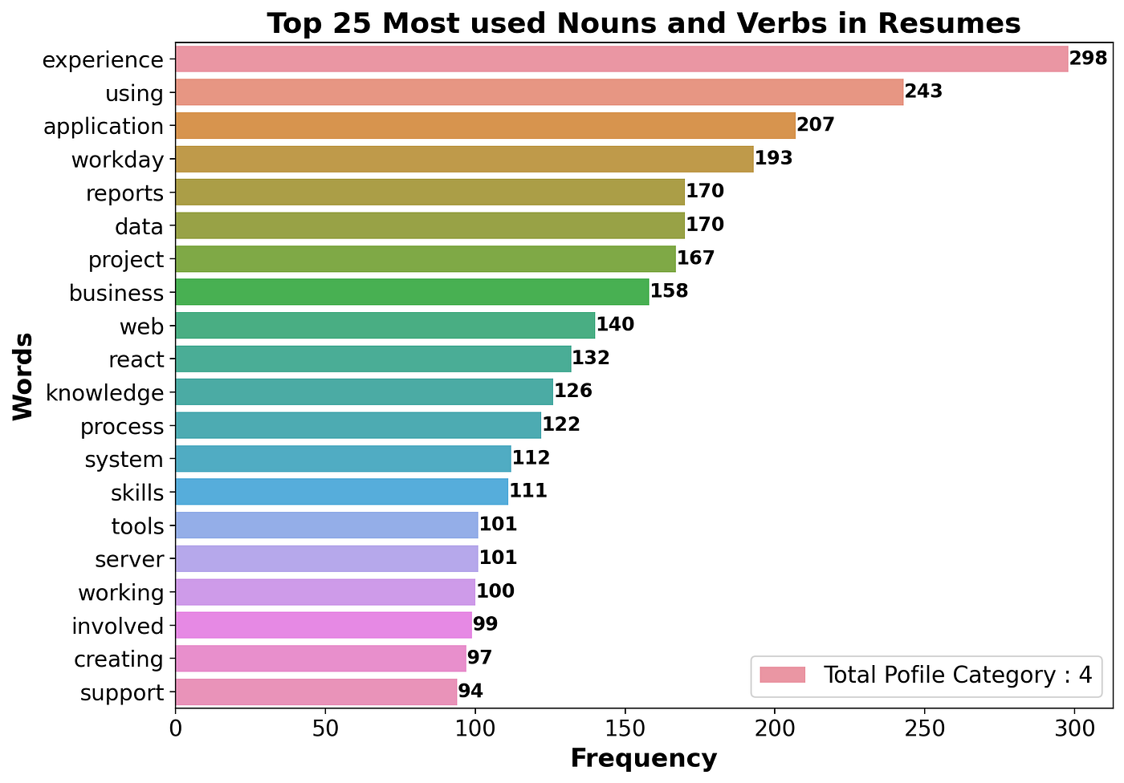
Figure 4: Visualization Table
6.12. Entity Recognition:
The displacy.render function in spaCy is indeed a powerful tool for visualizing entity recognition within raw text data. By leveraging this function, we can generate interactive visualizations that highlight various entities such as skills, organizations, locations, and more within resumes. The visualizations produced by displacy.render provide a user-friendly interface for exploring and understanding the structure of the text, making it easier to identify and extract important information. Additionally, the ability to customize the visualization style and layout further enhances its utility for analyzing resumes and other text documents. Overall, displacy.render is an invaluable feature in spaCy for facilitating entity recognition and gaining insights from textual data in a visually appealing manner.
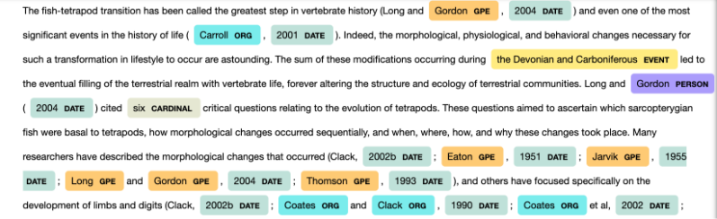

Figure 5: Resume dataset Entity Recognition

6.13. Dependency Parsing:
Indeed, visualizing dependency parsing using spaCy's displacy.render function with the "dep" style is a valuable technique for understanding the grammatical structure and relationships within text data. By specifying the "dep" style, the function generates visual representations of the syntactic dependencies between words in the text, illustrating how each word relates to other words in the sentence through various dependency relationships such as subject, object, modifier, etc. Limiting the visualization to a specific number of words, including spaces, provides a concise and focused view of the dependency structure, making it easier to analyze and interpret. Removing the word limit allows for visualization of the entire text, providing a comprehensive overview of the dependencies present within the document. Overall, visualizing dependency parsing using displacy.render offers valuable insights into the linguistic structure of the text, aiding in tasks such as syntactic analysis, information extraction, and natural language understanding.

6.14. Custom Entity Recognition:
In our instance, a new object named SKILL has been added, and it is shown in gray. Colors didn't impress me, and I also wanted to add a job description entity, so I started tinkering with different `displace settings.
Including Job-Category in the ruler of entities.
Giving each category a unique hue.
Gradient color additions for SKILL and Job-Category
6.15. Topic Modeling – LDA:
Latent Dirichlet Allocation (LDA) is indeed one of the most widely used topic modeling algorithms. In LDA, each document is represented as a mixture of topics, and each topic is represented as a distribution over words.
By analyzing this distribution, LDA infers the underlying topics present in the corpus and assigns documents to these topics based on their word distributions. In this scenario, we create a simple topic model with 4 topics, allowing us to uncover the main themes or subjects present in the corpus. This process enables us to gain insights into the dominant topics across the documents and facilitates tasks such as document categorization, summarization, and information retrieval.
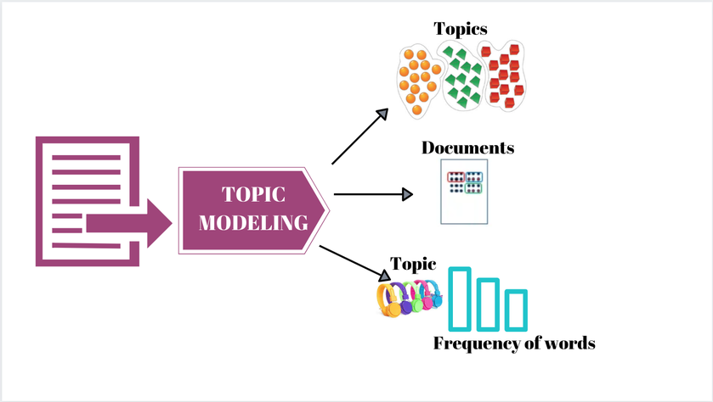
Figure 6: Latent Dirichlet Allocation

6.16. PyLDAvis:
PyLDAvis is indeed a powerful tool for visualizing and interpreting topics generated by topic modeling algorithms such as Latent Dirichlet Allocation (LDA) from Gensim. In the context described, the topics identified by the LDA model exhibit clear thematic patterns:
Topic #1: Customer-related topics, possibly including discussions about customer service, satisfaction, demographics, and geographical locations such as states and cities.
Topic #2: Management and marketing themes, indicating discussions on strategic management practices, marketing strategies, campaigns, and market analysis.
Topic #3: Systems and projects, suggesting conversations about system development, project management methodologies, software engineering, and implementation strategies.
Topic #4: Financial and company-related topics, likely encompassing discussions on financial management, investment strategies, company performance, and corporate governance.
By visualizing these topics using PyLDAvis, stakeholders can gain deeper insights into the main themes present in the corpus and understand how different topics relate to each other. This visualization aids in topic interpretation, exploration, and refinement, ultimately facilitating a more nuanced understanding of the underlying content.
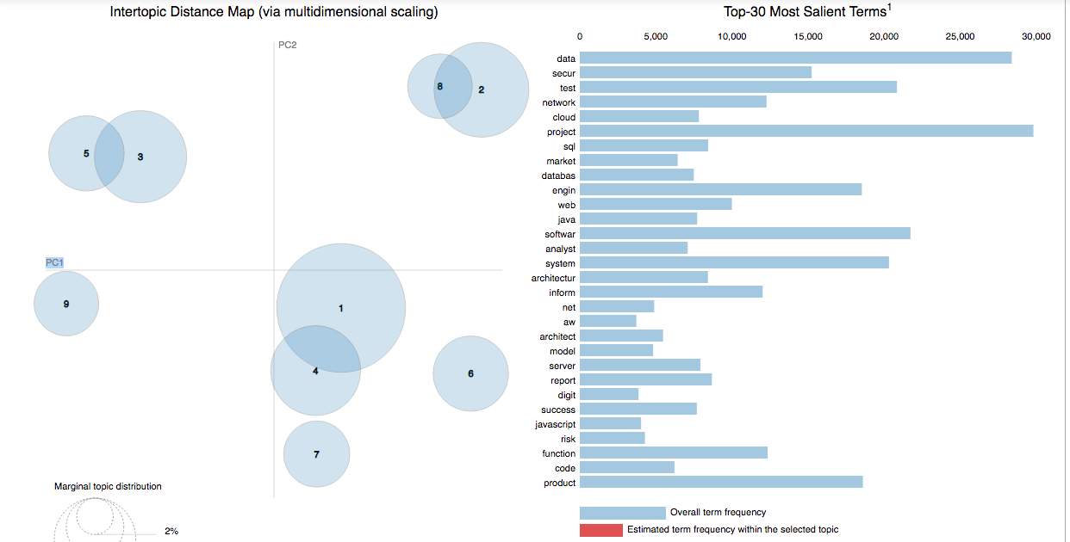

Figure 7: Intertopic Distance Map

VII. IMPLEMENTATION
automated resume analysis involves utilizing natural language processing (NLP) techniques to extract key information from resumes. Initially, the resumes are preprocessed to remove irrelevant content and standardized into a uniform format. Then, NLP algorithms are employed to parse the text, extracting pertinent details such as education history, work experience, skills, and certifications. Machine learning models can be trained on annotated datasets to classify resumes based on criteria such as job suitability or level of experience. Additionally, semantic analysis techniques can be applied to infer contextual information and assess the quality of the candidate's qualifications. Finally, the system can generate reports or rankings to aid recruiters in efficiently screening and selecting candidates.
7.1. Importing Libraries
In automated resume analysis, several libraries are essential for implementing natural language processing (NLP) and machine learning algorithms. Python's NLTK (Natural Language Toolkit) and spaCy libraries provide robust tools for text preprocessing, tokenization, and named entity recognition, enabling efficient extraction of relevant information from resumes. For machine learning tasks such as classification or ranking, libraries like scikit-learn offer a wide range of algorithms and utilities for model training and evaluation. Additionally, libraries such as Gensim or TensorFlow can be utilized for advanced NLP tasks like topic modeling or deep learning-based document embeddings. Moreover, libraries like Pandas facilitate data manipulation and analysis, while Matplotlib or Seaborn can be employed for visualization purposes, aiding in insights generation from the analyzed resume data.

CODING:
import spacy
from spacy.pipeline import EntityRuler
from spacy.lang.en import English
from spacy.tokens import Doc

import gensim
from gensim import corpora

from spacy import displacy
import pyLDAvis.gensim_models
from wordcloud import WordCloud
import plotly.express as px
import matplotlib.pyplot as plt

import pandas as pd
import numpy as np
import jsonlines

import re
import nltk
from nltk.corpus import stopwords
from nltk.stem import WordNetLemmatizer
nltk.download(['stopwords','wordnet'])
import warnings
warnings.filterwarnings('ignore')

7.2. Importing Dataset
In automated resume analysis, importing datasets involves gathering a diverse collection of resumes representing various job roles, industries, and experience levels. These resumes are typically obtained from online job boards, recruitment agencies, or internal databases. Once acquired, the resumes are preprocessed to standardize formatting and remove any sensitive or irrelevant information. Additionally, metadata such as job titles, industries, and years of experience may be extracted to facilitate categorization and analysis. Finally, the dataset is partitioned into training, validation, and testing sets for the development and evaluation of machine learning models and NLP algorithms aimed at extracting relevant information from resumes and making informed decisions during the recruitment process.
CODING:
df = pd.read_csv("/work/resume-dataset/Resume/Resume.csv")
df = df.reindex(np.random.permutation(df.index))
data = df.copy().iloc[
0:200,
]
data.head()
OUTPUT:
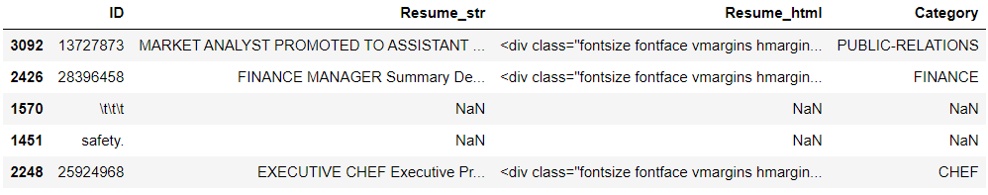
7.3. Loading spaCy model:
To load the spaCy model into Python, you can use the command python -m spacy download en_core_web_lg to download the large English model, which includes word vectors. Once downloaded, you can load the model into your Python script using the spacy.load() function. For instance, after installing spaCy and downloading the model, you can load it into a variable named nlp with the following code: import spacy and then nlp = spacy.load('en_core_web_lg'). This loads the model, enabling you to perform various natural language processing tasks such as tokenization, part-of-speech tagging, named entity recognition, and word vector representations.
CODING:
nlp = spacy.load("en_core_web_lg")
skill_pattern_path = "jz_skill_patterns.jsonl"
7.4. Entity Ruler:
To incorporate an entity ruler into a spaCy pipeline, you first need to add it as a component using nlp.add_pipe(). This pipeline component enables the incorporation of additional rules to identify specific entities within the text, such as skills or job descriptions. After adding the entity ruler, you can load a .jsonl file containing predefined patterns or rules for entities, such as a list of skills or job titles. Once loaded, the entity ruler can automatically recognize and annotate these entities within the text, enhancing the capability of the NLP model to extract relevant information for tasks such as resume analysis or job matching. This approach enables more precise and efficient identification of key information, contributing to the effectiveness of automated processes in tasks related to recruitment or text analysis.

CODING:
ruler = nlp.add_pipe("entity_ruler")
ruler.from_disk(skill_pattern_path)
nlp.pipe_names

OUTPUT:
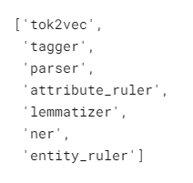
7.5. Skills:
The two Python functions, get_skills and unique_skills, serve the purpose of skill extraction and deduplication, respectively, from a given text. The get_skills function utilizes NLP techniques to extract potential skills from a single text, employing methods such as pattern matching or keyword extraction. Once extracted, the unique_skills function filters out duplicate entries, ensuring that each skill is represented only once in the resulting array. This combination of functions allows for the creation of a comprehensive list of unique skills from multiple texts, facilitating the analysis of trends and patterns within the dataset and aiding in tasks such as skill mapping or proficiency assessment.
CODING:
def get_skills(text):
doc = nlp(text)
myset = []
subset = []
for ent in doc.ents:
if ent.label_ == "SKILL":
subset.append(ent.text)
myset.append(subset)
return subset
def unique_skills(x):
return list(set(x))
7.6. Cleaning Resume Text:
To clean the resume text using the NLTK library, several steps will be implemented. Initially, regular expressions (regex) will be employed to eliminate hyperlinks, special characters, and punctuations, ensuring a cleaner dataset. Subsequently, the text will be converted to lowercase to standardize the case across all words. Next, the text will be split into an array based on spaces, facilitating further processing. Following this, lemmatization will be applied to transform words into their base forms for normalization, enhancing consistency and reducing redundancy. English stopwords, such as common words like "the" or "is," will then be removed to focus on meaningful content. Finally, the cleaned text will be appended into an array, ready for subsequent analysis or processing. This comprehensive cleaning process enhances the quality of the dataset, enabling more accurate and effective text analysis tasks.
CODING:
clean = []
for i in range(data.shape[0]):
review = re.sub(
'(@[A-Za-z0-9]+)|([^0-9A-Za-z \t])|(\w+:\/\/\S+)|^rt|http.+?"',
" ",
data["Resume_str"].iloc[i],
)
review = review.lower()
review = review.split()
lm = WordNetLemmatizer()
review = [
lm.lemmatize(word)
for word in review
if not word in set(stopwords.words("english"))
]
review = " ".join(review)
clean.append(review)
7.7. Applying functions:
In this section, we'll apply the functions previously created to preprocess the resume data. Firstly, we'll create a "Clean_Resume" column and populate it with the cleaned resume text by removing hyperlinks, special characters, punctuations, converting to lowercase, splitting into an array, lemmatizing, and removing English stopwords. Next, we'll create a "Skills" column where we'll lowercase the text and apply the get_skills function to extract skills from each resume. This step ensures that skills are identified consistently across all resumes. Finally, we'll remove duplicates from the "Skills" column to ensure that each skill is represented only once, providing a clean and concise list of unique skills extracted from the resumes. This process prepares the dataset for further analysis, such as skill trend visualization or matching with job requirements.
CODING:
data["Clean_Resume"] = clean
data["skills"] = data["Clean_Resume"].str.lower().apply(get_skills)
data["skills"] = data["skills"].apply(unique_skills)
data.head()
OUTPUT:

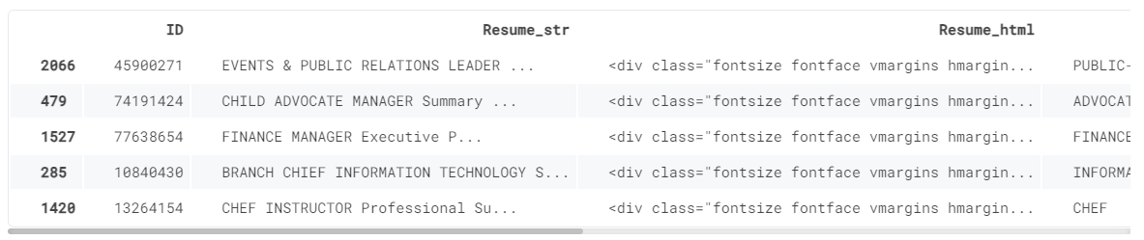
7.8. Visualization:
In automated resume analysis, visualization plays a crucial role in providing insights into the dataset and aiding in decision-making processes. Various visualization techniques can be applied to showcase different aspects of the data. For instance, word clouds can be used to visualize the most frequently occurring skills or keywords in resumes, providing an overview of the skillset prevalent among candidates. Bar charts or histograms can illustrate the distribution of skills or experience levels across different job roles or industries, helping recruiters identify common trends and preferences. Additionally, scatter plots or heatmaps can visualize correlations between skills or experiences, highlighting potential skill combinations or patterns. Interactive dashboards can also be developed to enable dynamic exploration of the data, allowing users to filter and drill down into specific subsets of resumes based on criteria such as skill proficiency or education level. Overall, visualization techniques enhance the interpretability and usability of automated resume analysis systems, empowering recruiters to make informed decisions efficiently.
7.9. Jobs Distribution:
In the random sample of 200 resumes, a diverse range of job categories is evident. Notably, Accountants, Business Development professionals, and Advocates emerge as the most prevalent categories. This distribution underscores the varied professional backgrounds and career trajectories represented within the dataset, reflecting the multidimensional nature of the job market. Such insights gleaned from the distribution of job categories can inform recruitment strategies and talent acquisition efforts, helping organizations align their hiring practices with prevalent industry trends and demands.
CODING:
fig = px.histogram(
data, x="Category", title="Distribution of Jobs Categories"
).update_xaxes(categoryorder="total descending")
fig.show()
OUTPUT:
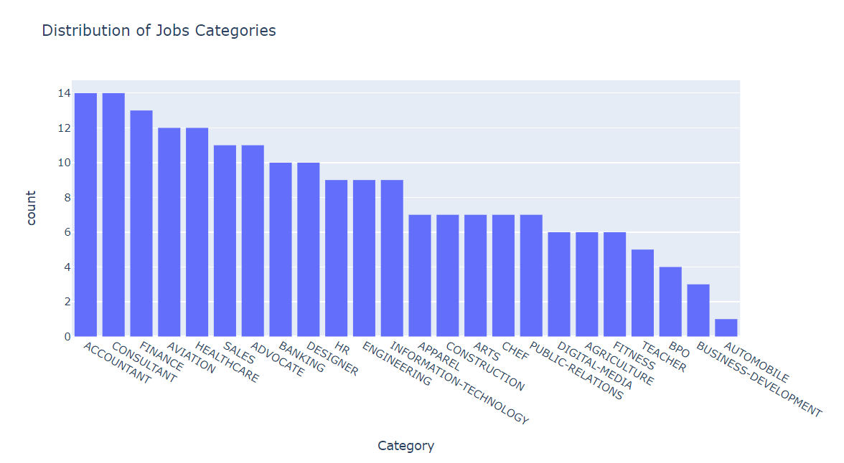
Figure 8: Job Categories
7.10. Skills:
Initially, we'll utilize the unique() function to extract distinct skill categories from the dataset, ensuring to include an "ALL" category to capture the overall trend. Subsequently, we'll leverage input cells to import these categories as variables, facilitating seamless visualization and analysis of skills across different job descriptions. This approach enables a comprehensive understanding of skill distribution within the dataset, aiding in targeted insights for recruitment or skill development strategies.
Top Skills:
- Software
- Support
- Business
CODING:
Job_cat = data["Category"].unique()
Job_cat = np.append(Job_cat, "ALL")
OUTPUT:
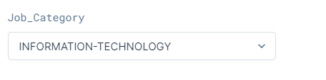
CODING:
Total_skills = []
if Job_Category != "ALL":
fltr = data[data["Category"] == Job_Category]["skills"]
for x in fltr:
for i in x:
Total_skills.append(i)
else:
fltr = data["skills"]
for x in fltr:
for i in x:
Total_skills.append(i)

fig = px.histogram(
x=Total_skills,
labels={"x": "Skills"},
title=f"{Job_Category} Distribution of Skills",
).update_xaxes(categoryorder="total descending")
fig.show()
OUTPUT:
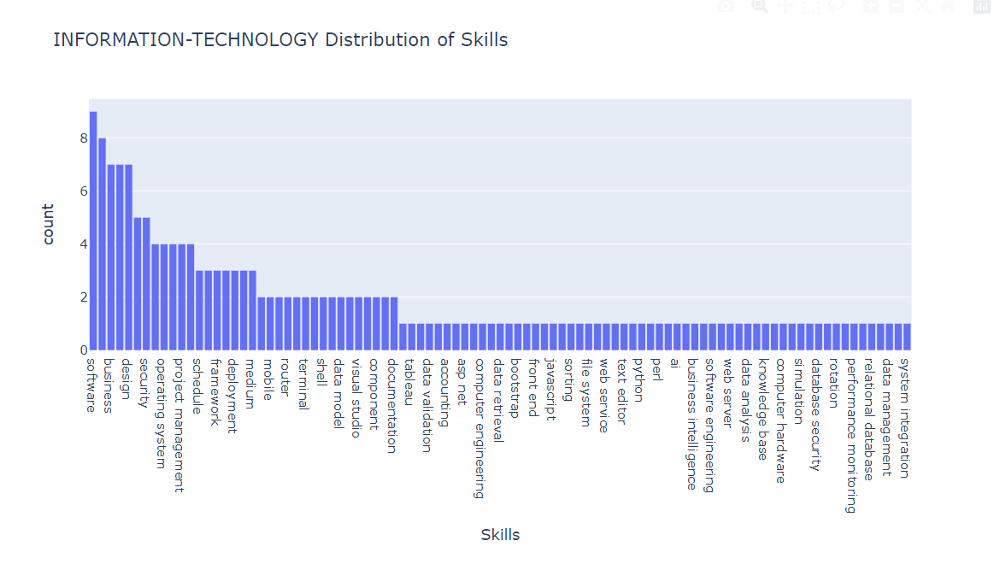
Figure 9: Skill Distribution
7.11. Most used words:
In the section, we delve into analyzing resumes filtered by job category to identify prevalent terms. For instance, within the Information Technology domain, common words such as "system," "network," and "database" emerge as primary descriptors. By examining word clouds, we can uncover additional patterns and themes, providing valuable insights into the prevalent skills and expertise sought after within specific job categories. This exploration enhances our understanding of the skill landscape and aids in tailoring recruitment strategies or refining job descriptions to align with industry demands.
CODING:
text = ""
for i in data[data["Category"] == Job_Category]["Clean_Resume"].values:
text += i + " "
plt.figure(figsize=(8, 8))
x, y = np.ogrid[:300, :300]
mask = (x - 150) ** 2 + (y - 150) ** 2 > 130 ** 2
mask = 255 * mask.astype(int)
wc = WordCloud(
width=800,
height=800,
background_color="white",
min_font_size=6,
repeat=True,
mask=mask,)
wc.generate(text)
plt.axis("off")
plt.imshow(wc, interpolation="bilinear")
plt.title(f"Most Used Words in {Job_Category} Resume", fontsize=20)

OUTPUT:
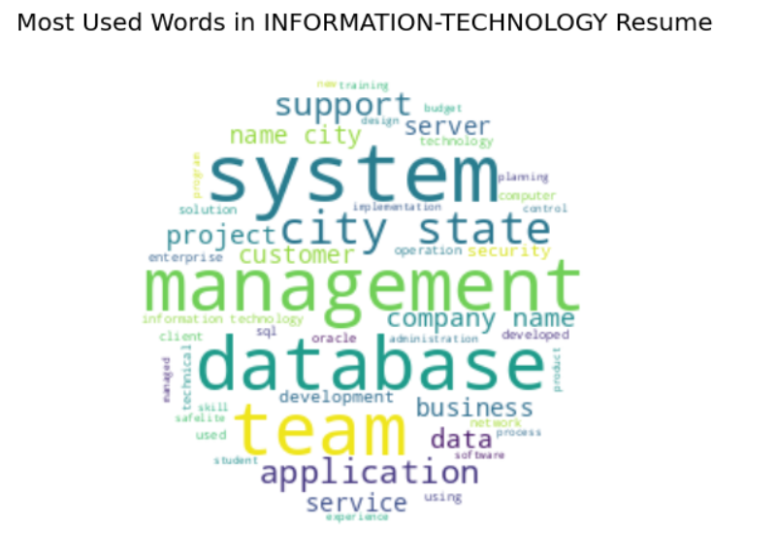
Figure 10: Most Used Words

7.12. Entity Recognition:
Incorporating spaCy's displacy.render function adds a dynamic dimension to entity recognition within raw text, offering a comprehensive view of the document. This powerful tool enables the identification of key entities such as skills or general employment patterns (GEP) embedded within resumes. Its intuitive visualization enhances the understanding of the document's content, facilitating efficient extraction and analysis of pertinent information for recruitment or skill assessment purposes.

CODING:
sent = nlp(data["Resume_str"].iloc[0])
displacy.render(sent, style="ent", jupyter=True)

OUTPUT:

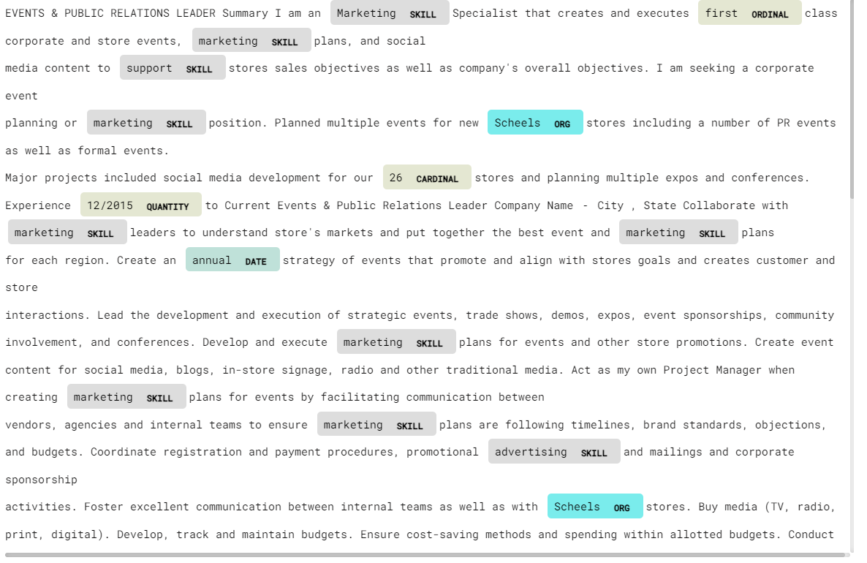
Figure 11: Entity Recognition

7.13. Dependency Parsing:
Utilizing dependency parsing with the 'dep' style offers a concise yet insightful visualization of relationships within text, particularly when restricted to a limited word count. This focused approach enhances clarity by presenting a smaller chunk of data, facilitating easier interpretation of dependencies between words. Adjusting the filter allows for a deeper exploration of linguistic structures, aiding in discerning nuanced connections and dependencies within the text, crucial for comprehensive analysis and understanding.
CODING:
displacy.render(sent[0:10], style="dep", jupyter=True, options={"distance": 90})
OUTPUT:
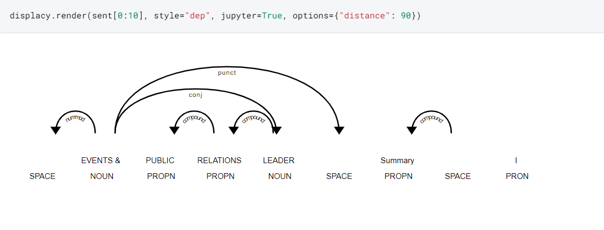
Figure 12: Dependency Parsing

7.14. Custom Entity Recognition:
Incorporating custom entity recognition, such as SKILL and Job Description, enhances the analysis of resumes, with SKILL entities displayed in a distinctive gradient color scheme for improved visibility. Experimenting with parameters within displacy, I've also fine-tuned color schemes to ensure clarity and coherence, ensuring each entity, including the newly added Job-Category, is easily discernible. This iterative approach optimizes visualization, facilitating more nuanced insights into the document's content and aiding in efficient categorization and analysis for recruitment or skill assessment purposes.
CODING:
patterns = df.Category.unique()
for a in patterns:
ruler.add_patterns([{"label": "Job-Category", "pattern": a}])

colors = {
"Job-Category": "linear-gradient(90deg, #aa9cfc, #fc9ce7)",
"SKILL": "linear-gradient(90deg, #9BE15D, #00E3AE)",
"ORG": "#ffd966",
"PERSON": "#e06666",
"GPE": "#9fc5e8",
"DATE": "#c27ba0",
"ORDINAL": "#674ea7",
"PRODUCT": "#f9cb9c",
}

options = {
"ents": [
"Job-Category",
"SKILL",
"ORG",
"PERSON",
"GPE",
"DATE",
"ORDINAL",
"PRODUCT",
],
"colors": colors,
}

sent = nlp(data["Resume_str"].iloc[5])
displacy.render(sent, style="ent", jupyter=True, options=options)

OUTPUT:

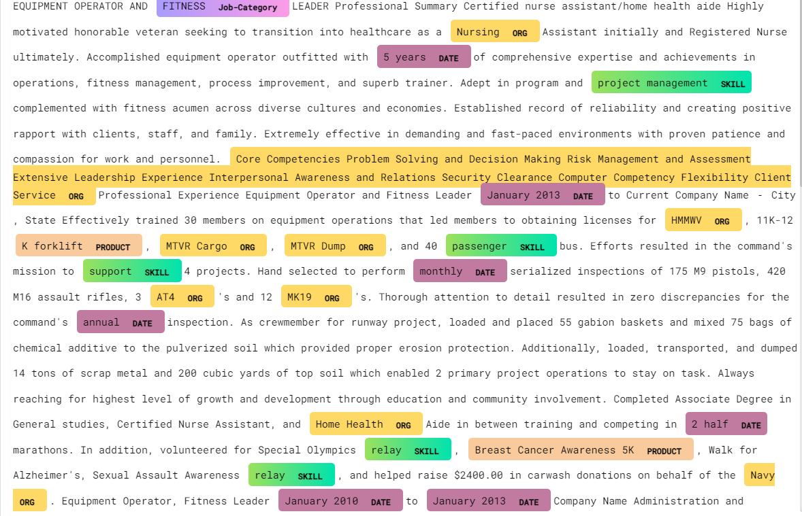
Figure 13: Custom Entity Recognition

7.15. Resume Anlaysis:
Users can seamlessly copy and paste their resumes, allowing the model to perform comprehensive analysis and highlight various skills embedded within the text. The results are indeed impressive, as the model accurately identifies and highlights all relevant skills, facilitating a thorough understanding of the individual's expertise and qualifications. This feature streamlines the process of resume evaluation, providing valuable insights for both job seekers and recruiters alike.

CODING:
sent2 = nlp(input_resume)
displacy.render(sent2, style="ent", jupyter=True, options=options)
OUTPUT:
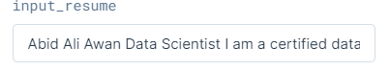

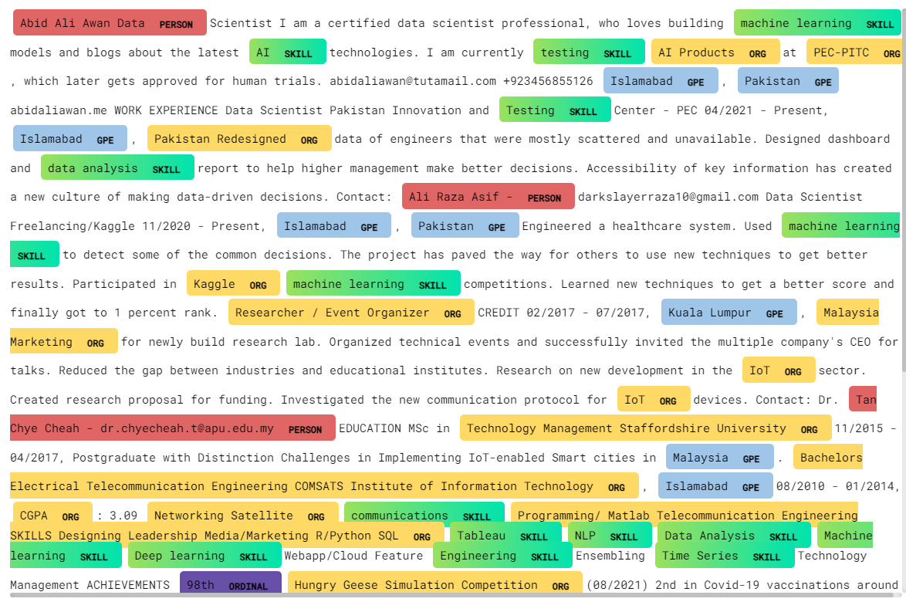
Figure 14: Resume Analysis
7.16. Match Score:
In addition to the time-saving benefits, the automated skill-matching system enhances the objectivity of the recruitment process by relying on quantifiable data rather than subjective judgments. Recruiters can customize the weighting of different skills, ensuring that the system prioritizes the most critical qualifications for each specific role. This not only expedites the initial screening process but also contributes to a more accurate shortlisting of candidates. The streamlined approach fosters a more inclusive hiring process, as it minimizes the potential for unconscious biases by focusing on measurable competencies.

Furthermore, this technology allows recruiters to stay ahead of industry trends by easily adapting skill requirements to evolving job market demands. The system's ability to analyze and adapt to changing skill landscapes ensures that the recruitment process remains agile and responsive. As a result, organizations can maintain a competitive edge by swiftly identifying and acquiring top talent with the most relevant skills. This feature also supports the development of talent pipelines, enabling recruiters to proactively identify and engage potential candidates for future opportunities. Ultimately, the integration of this advanced technology not only optimizes the efficiency of recruitment but also contributes to a more strategic and forward-thinking approach to talent acquisition.
CODING:
req_skills = input_skills.lower().split(",")
resume_skills = unique_skills(get_skills(input_resume.lower()))
score = 0
for x in req_skills:
if x in resume_skills:
score += 1
req_skills_len = len(req_skills)
match = round(score / req_skills_len * 100, 1)

print(f"The current Resume is {match}% matched to your requirements")
OUTPUT:
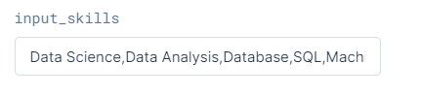
CODING:
print(resume_skills)

OUTPUT:
7.17. Topic Modeling – LDA:
In this section, we implement Latent Dirichlet Allocation (LDA), one of the most renowned topic modeling algorithms, to extract insights from textual data. By employing LDA with four topics, we aim to uncover latent themes and patterns within the dataset. This straightforward approach allows for the identification of key topics, enabling a deeper understanding of the underlying structure and content of the text. Through topic modeling with LDA, we can effectively organize and categorize textual data, facilitating enhanced analysis and interpretation for various applications such as content understanding, recommendation systems, and information retrieval.
CODING:
docs = data["Clean_Resume"].values
dictionary = corpora.Dictionary(d.split() for d in docs)
bow = [dictionary.doc2bow(d.split()) for d in docs]
lda = gensim.models.ldamodel.LdaModel
num_topics = 4
ldamodel = lda(
bow,
num_topics=num_topics,
id2word=dictionary,
passes=50,
minimum_probability=0
)
ldamodel.print_topics(num_topics=num_topics)
OUTPUT:
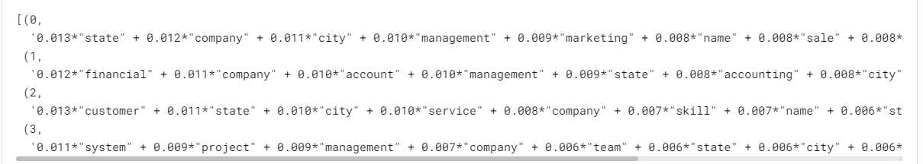

7.18. pyLDAvis:
Utilizing pyLDAvis from Gensim, we can create insightful visualizations of topics extracted through LDA modeling. Based on the analysis, it appears that topic #1 pertains to customer-related aspects, including state and city information.
Topic #2 seems to focus on management and marketing themes, while topic #3 appears to revolve around systems and projects. Finally, topic #4 appears to be centered on financial matters and company-related discussions. Through pyLDAvis visualizations, we gain valuable insights into the predominant themes and topics present within the textual data, facilitating deeper understanding and interpretation for various analytical purposes.
CODING:
pyLDAvis.enable_notebook()
pyLDAvis.gensim_models.prepare(ldamodel, bow, dictionary)

OUTPUT:
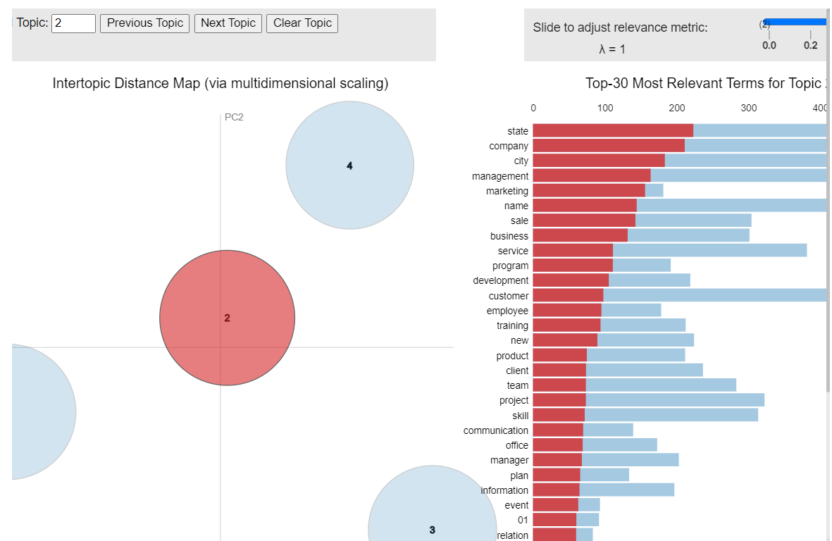

Figure 15: pyLDAvis visualizations

VIII. CONCLUSION
In the course of this project, our collaboration with spaCy has been both enlightening and transformative. The extensive leveraging of spaCy's capabilities, particularly through the adept use of the entity ruler, has broadened our approach to entity recognition. The incorporation of customized visualizations, adorned with bespoke colors, has elevated the clarity of our analyses, providing recruiters with a more intuitive and efficient means of navigating through extracted information. As we delved into skills distribution visualization, our project introduced a seamless resume analysis feature, empowering recruiters to swiftly identify and match candidates with the desired skillsets, thereby enhancing the precision of candidate evaluation in the recruitment process. Furthermore, the integration of Latent Dirichlet Allocation (LDA) for topic modeling has been a pivotal addition, offering deeper insights into the inherent themes within textual data. The use of pyLDAvis as a visualization tool has not only enhanced the interpretability of these insights but also contributed to a more comprehensive understanding of the diverse topics encapsulated in the resumes. This multifaceted exploration not only solidified our technical proficiency with spaCy but also shed light on innovative avenues for optimizing the hiring process. The transformative potential of natural language processing in talent acquisition and recruitment strategies has been underscored, marking this project as a significant step towards reshaping and modernizing the landscape of candidate screening and evaluation.

REFERENCES
[1] D. Çelik et al., "Towards an Information Extraction System Based on Ontology to Match Resumes and Jobs," 2013 IEEE 37th Annual Computer Software and Applications Conference Workshops, Japan, 2013, pp. 333-338.
[2] F. N. A. Al Omran and C. Treude, "Choosing an NLP Library for Analyzing Software Documentation: A Systematic Literature Review and a Series of Experiments," 2017 IEEE/ACM 14th International Conference on Mining Software Repositories (MSR), Buenos Aires, 2017, pp. 187-197.
[3] Zhang C, Wang H (2018) ResumeVis: a visual analytics system to discover semantic information in semi-structured resume data. ACM Trans Intell Syst Technol 10(1), Article 8, 25 p. https://doi.org/10.1145/3230707.
[4] Chala, S.A.; Ansari, F.; Fathi, M.; Tijdens, K. Semantic matching of job seeker to vacancy: A bidirectional approach. Int. J. Manpow. 2018, 39, 1047–1063.
[5] Pudasaini, S.; Shakya, S.; Lamichhane, S.; Adhikari, S.; Tamang, A.; Adhikari, S. Scoring of Resume and Job Description Using Word2vec and Matching Them Using Gale-Shapley Algorithm. In Proceedings of the ICOECA 2021, Bangalore, India, 18–19 February 2021.
[6] Kawan, S.; Mohanty, M.N. Multiclass Resume Categorization Using Data Mining. Int. J. Electr. Eng. Technol. 2020, 11, 267–274.
[7] R. P. Kumar, S. S. Chowdhary and R. Bhatia, "A machine learning approach for automation of resume recommendation system", Procedia Computer Science, vol. 167, pp. 2318-2327, 2020.
[8] T. Quynh and T.T. Dang, "Automatic Process Resume In Talent Pool By Applying Natural Language Processing", International Conference On Logistics And Industrial Engineering 2021, 2021.
[9] K. Satheesh et al., "Resume Ranking based on Job Description using SpaCy NER model", International Research Journal of Engineering and Technology (IRJET), vol. 7, no. 05, 2020, ISSN 2395–0056.
[10] D. Çelik et al., "Towards an Information Extraction System Based on Ontology to Match Resumes and Jobs," 2013 IEEE 37th Annual Computer Software and Applications Conference Workshops, Japan, 2013, pp. 333-338.
[11] S. K. Kopparapu, "Automatic extraction of usable information from unstructured resumes to aid search," 2010 IEEE International Conference on Progress in Informatics and Computing, Shanghai, 2010, pp. 99-103.
[12] Chandola, D., Garg, A., Maurya, A., Kushwaha, A.: Online Resume Parsing System Using Text Analytics (2015). [online] Jmdet.com. Available at: http://www.jmdet.com/wp-content/uploads/2015/08/CR9.pdf. Accessed 24 Sept. 2020.
[13] Singh, S.: Natural Language Processing for Information Extraction (2018). arXiv, [online] Available at: https://arxiv.org/pdf/1807.02383.pdf. Accessed 20 Jan. 2021.
[14] C. H. Ayishathahira, C. Sreejith and C. Raseek, "Combination of Neural Networks and Conditional Random Fields for Efficient Resume Parsing", 2018 International CET Conference on Control Communication and Computing (IC4), pp. 388-393, 2018, July.
[15] Kopparapu, S.K., 2010, December. Automatic extraction of usable information from unstructured resumes to aid search. In 2010 IEEE International Conference on Progress in Informatics and Computing (Vol. 1, pp. 99-103). IEEE.
[16] SW. Kim, JM. Gil, Research paper classification systems based on TF-IDF and LDA schemes. Hum. Cent. Comput. Inf. Sci. 9, 30 (2019).
[17] A. Zaroor, M. Maree, MuathSabhaJRC, A job post and resume classification system for online recruitment, International Conference on tools with Artifical Intelligence, (2017).
[18] Kolluri, Johnson and Razia, Shaik and Nayak, Soumya Ranjan, Text Classification Using Machine Learning and Deep Learning Models. International Conference on Artificial Intelligence in Manufacturing & Renewable Energy (ICAIMRE) (2019).
[19] Anushka Agarwal, Dr. Senthilkumar. "Resume Recommendation System Using Cosine Similarity." International Research Journal of Modernization in Engineering Technology and Science, April 2022.
[20] Pradeep Kumar Roya, Sarabjeet Singh Chowdhary, Rocky Bhatia. "A Machine Learning approach for automation of Resume Recommendation system." International Conference on Computational Intelligence and Data Science (ICCIDS 2019).
[21] Nirali Bhaliya, Jay Gandhi, Dheeraj Kumar Singh. "NLP based Extraction of Relevant Resume using Machine Learning." International Journal of Innovative Technology and Exploring Engineering (IJITEE), Volume-9 Issue-7, May 2020.

